# PROFESSIONAL TRAINING REPORT

**At**

# SATHYABAMA INSTITUTE OF SCIENCE AND TECHNOLOGY (DEEMED TO BE UNIVERSITY)

Submitted in partial fulfillment of the requirements for the award of Bachelor of Engineering Degree in

COMPUTER SCIENCE AND ENGINEERING

By

**Srinivas prasad. P**

**(Reg. No. 39110775)**



# DEPARTMENT OF COMPUTER SCIENCE AND ENGINEERING

# SCHOOL OF COMPUTING

**SATHYABAMA INSTITUTE OF SCIENCE AND TECHNOLOGY (DEEMED TO BE UNIVERSITY)**

**(Established under Section 3 of UGC Act, 1956)**

### Jeppiaar Nagar, Rajiv Gandhi Salai, Chennai - 600119

**www.sathyabamauniversity. ac.in**

**APRIL 2022**

|  |  |  |
| --- | --- | --- |
|  | **SATHYABAMA**  **INSTITUTE OF SCIENCE AND TECHNOLOGY** (DEEMED TO BE UNIVERSITY) **Accredited with Grade “A” by NAAC**  (Established under Section 3 of UGC Act, 1956)  JEPPIAAR NAGAR, RAJIV GANDHI SALAI  CHENNAI– 600119  [**www.sathyabama.ac.in**](http://www.sathyabama.ac.in) |  |

# DEPARTMENT OF COMPUTER SCIENCE AND ENGINEERING

**BONAFIDE CERTIFICATE**

### This is to certify that this Project Report is the BONAFIDE work of SRINIVASPRASAD.P (Reg. No: 39110775) who carried out the project entitled “SRINIVAS TICKET RESERVATION-Online Ticket Reservation System App” under my supervision from March 2022 to April 2022.

## Internal Guide

## Dr . A. JESUDOSS

## **Head of the Department**

## **Dr .L. Lakshmanan, M.E., Ph.D.,**



## Submitted for Viva voce Examination held on

**Internal Examiner External Examiner**

**DECLARATION**

I, SRINIVASPRASAD.P (Reg. No. 39110775) hereby declare that the Project report entitled **"SRINIVAS TICKET RESERVATION - Online Ticket Reservation System App"** done by me under the guidance of **Dr. A. JESUDOSS** is submitted in partial fulfillment of the requirements for the award of Bachelor of degree in Information Technology.

### DATE:

**PLACE: SIGNATURE OF THE CANDIDATE**

### ACKNOWLEDGEMENT

I am pleased to acknowledge my sincere thanks to Board of Management of

**SATHYABAMA INSTITUTE OF SCIENCE AND TECHNOLOGY** for their kind

encouragement in doing this project and for completing it successfully. I am grateful to them.

I convey my thanks to **Dr. T.SASIKALA, M.E., Ph.D., Dr. S. Vigneshwari , M.E., Ph.D. and Dr. L. Lakshmanan, M.E., Ph.D., Heads of the Department** of **Computer Science** for providing me necessary support and details at the right time during the progressive reviews.

I would like to express my sincere and deep sense of gratitude to my Project Guide **Dr. A. JESUDOSS ,** for her valuable guidance, suggestions and constant encouragement paved way for the successful completion of my project work.

I wish to express my thanks to all Teaching and Non-teaching staff members of the **Department OF COMPUTER SCIENCE AND ENGINEERING** who were helpful in many ways for the completion of the project.

**TRAINING CERTIFICATE**

# ABSTRACT

SRINIVAS TICKET RESERVATION is software you can use for managing reservations for your service. Be it a pool, fitness centre, gym, yoga studio, or a parks & recreation centre an Online Reservation System allows all kinds of service businesses to accept bookings and appointments online and manage their phone and in-person bookings with ease.

Basically, an online reservation system allows a potential customer to book and pay for a service directly through a website. That means from the moment a customer decides they want to book a slot for your service (be it an in-house class or online appointment) to choosing a date, picking a time, and paying for the booking, membership management, everything is handled online! It greatly reduces your workload and removes the opportunity for double-bookings.

We now live in a world where almost everything is practically inseparable from the internet, businesses topping the list. It's now crucial that every business has a recognizable online presence, no matter its sector. Not only does modern technology help businesses get found online, but it also helps them easily convert visits into revenue through an online reservation system.

SRINIVAS TICKET RESERVATION – An Online Ticket Reservation App helps you in increasing booking, saves time, increases efficiency of operations etc. In this app once the user gets started, the user has to select their schedule of journey (boarding, destination and date of journey). Then the next step is to select the type of accommodation according to the feasibility and enter the passenger count. Followed by passenger information where the user has to enter the details of the person who booked tickets and details of the passengers. The last step is the ticket generation i.e., the entire travel journey with all the above entered details will be generated.

There exists a separate portal for admin where he/she can login with their respective username and password. After login, the admin can search passengers, control the booked passengers i.e., he/she can decline their tickets and provide refund. The admin can accept the passenger payment and give them concession and can check the transaction history.

Overall, TICKETS READY is a very helpful app in booking tickets in a reasonable price!!

i

### TABLE OF CONTENTS

**Chapter No.**

### TITLE Page

**No.**

ABSTRACT i

LIST OF FIGURES ii

LIST OF TABLES iii

LIST OF ABBREVATIONS iii

1. INTRODUCTION 1

WHAT IS ONLINE TICKET RESERVATION? 1

ROLE OF HTML, CSS, PHP & MYSQL 2

### 

### REQUIREMENTS FOR APPLICATION 3

### 

### 2. SRINIVAS TICEKT RESERVATION – TICKET BOOKING APP 4

OVERVIEW 4

FUNCTIONAL REQUIREMENTS 4

* + 1. COMPONENTS 5

OVERVIEW OF COMPONENTS 5

BACKEND 16

1. SUMMARY AND CONCLUSIONS 17

SUMMARY 17

CONCLUSIONS 17

REFERENCES 18

APPENDIX 18

1. SOURCE CODE 18
2. SCREENSHOTS 41

### LIST OF FIGURES

**FIGURE No. TITLE PAGE No.**

* 1. Home Page 6

1.2 About Us Page 7

1.3 Contact Us Page 8

1.4 Services Page 9

1.5 Schedule Page 10

1.6 Accommodation Page 11

1.7 Passenger Info Page 12

1.8 Payment Info Page 13

1.9 Admin Login Page 14

1.9.1 Reserved User Page 14

1.9.2 Accept Payment Page 15

1.9.3 Transactions Page 15

2 MYSQL Connection 16

### LIST OF TABLES

**TABLE No. TITLE PAGE No.**

2.1 Passenger Info Fields 12

### 

### LIST OF ABBREVIATIONS

App - Application

HTML - Hyper Text Markup Language

CSS - Cascading Style Sheets

Php - Hyper Text Pre Processor

MYSQL - Structured Query Language

**INTRODUCTION**

### What is Online Ticket Reservation?

 An online reservation system allows a potential customer to book and pay for a service directly through a website. That means from the moment a customer decides they want to book a slot for your service (be it an in-house class or online appointment) to choosing a date, picking a time, and paying for the booking, membership management, everything is handled online! It greatly reduces the workload on your staff and removes the opportunity for double-bookings.

Here are the reasons why you should consider putting an online booking system for your service business in place:

* **It increases bookings:**

One of the most significant benefits of an online reservation system is that they are **always open for business.**You can accept bookings 24/7, so your customers don't have to wait until the next day to make a reservation or worse, turn to one of your competitors. Clients have the convenience to book when it's right for them, and you collect bookings while you sleep. Plus, bookings can be made at their own convenience from the comfort of their home. Eliminate the need to call up the facility to ask for details or go to one and struggle to find a suitable slot to book. Your business can keep its calendars full throughout the year!

* **It saves time:**

Online reservation system helps you do more with less by delegating the booking-related tasks to an automated platform. A reservation system enables you to **automate notifications** to your clients. Once you have your business set up on the platform, you won't have to call your guests for reminders or send follow-up emails, which also means a drastic reduction of no-shows, and you don't lose out on your income! All of this runs in the background, so you and your staff can focus on providing the best experience to your clients.

* **It puts you ahead of your competition:**

There's a multitude of businesses out there who have a website and are listed on Google, but only a few have an online booking system in place. By having an online reservation system, you're one step ahead of the game, tipping the scales in your favor when prospects research and compare your capabilities against your competitors.

* **It increases efficiency of operations:**

Customers today expect instant gratification, and an online reservation system can help you provide it. Nobody in this day and age has the patience to wait at the front desk! Booking software can help you **manage your waitlist**. No more long queues at the front desk or having to say "one moment" to a customer waiting for you to get off the phone again! Avoid confusions that come with bookings, and automate everything with booking software with a waitlist management feature.

1

### Role of HTML, CSS, PHP & MYSQL:

### 

### A webpage can contain headings, paragraphs, images, videos, and many other types of data. Front end developers use the HTML element to specify what kind of information each item on a webpage contains — for instance, the “p” HTML element indicates a paragraph. Developers also write HTML language code to specify how different items relate to one another in the page’s overall structure or document structure.

### CSS is used for defining the styles for web pages. It describes the look and formatting of a document which is written in a markup language. It provides an additional feature to HTML. ... CSS helps us to control the text color, font style, the spacing between paragraphs, sizing of columns, layout designs, and many more. CSS provides these capabilities through a technical model based on a hierarchical scope of effect, the separation of style from content, and a well-defined set of published standards.

* PHP (Hypertext Preprocessor) is known as a general-purpose scripting language that can be used to develop dynamic and interactive websites. It was among the first server-side languages that could be embedded into HTML, making it easier to add functionality to web pages without needing to call external files for data.
* MYSQL database helps to automate data retrieving and provide great support in PHP MYSQL web application development.

### 2

### Requirements of Application:

### Create a workspace with VS Code

### Design the general layout with HTML & CSS

### Create the required components with PHP.

### A database should be made in MYSQL for the backend purpose.

### Instead of changing in code, admin can make changes in the database, so that the change gets reflected in the website also.

3

# SRINIVAS TICKET RESERVATION – AN ONLINE TICKET RESERVATION APP

**Overview:**

This project aims to maintain the information about the passengers those who are in need of booking train ticket. It will help the busy passengers to save their time and energy.

Admin will be able to login themselves and search data of the passengers using the search bar and for the admin purpose, transactions and reserved passenger’s control will be also available.

Only admin will be able to update passenger’s information. There are many components like schedule, accommodation etc. Once passenger gets started, they will be directed to various fields and finally the booking will be done. This app is done with HTML, CSS, Php and MYSQL.

The Tickets Ready App will be very easy and a delicate for the passengers to book their schedule. Now a days, internet is the most widely used network in modern world and no one is preferring to go out and booking their tickets. For their easy purpose, Tickets Ready app is made, so that users can book by sitting in their home itself.

**Functional Requirements:**

To build this application, the main thing needed is the components where are those booking process occur. The components used in this application are listed below:

4

**COMPONENTS:**

* Home
* About Us
* Contact Us
* Services
* Login (for admin purpose)
* Reserved User Control
* Accept Payment
* Transactions
* Schedule
* Accommodation
* Passenger Info
* Payment Info

**OVERVIEW OF COMPONENTS:**

* **Home Page:**

The home page is the first page of this application, from where we can initialize our booking process.

5

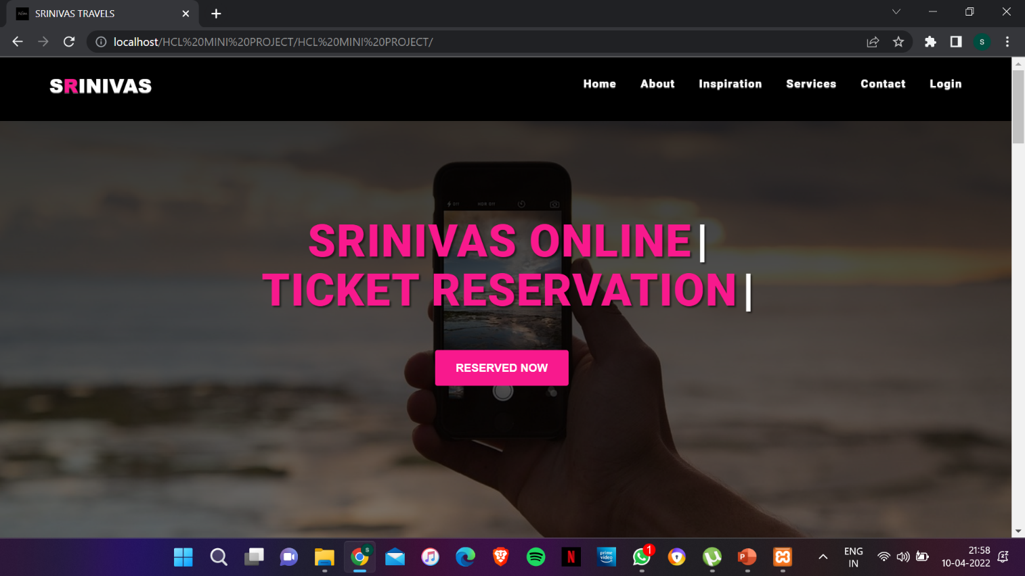

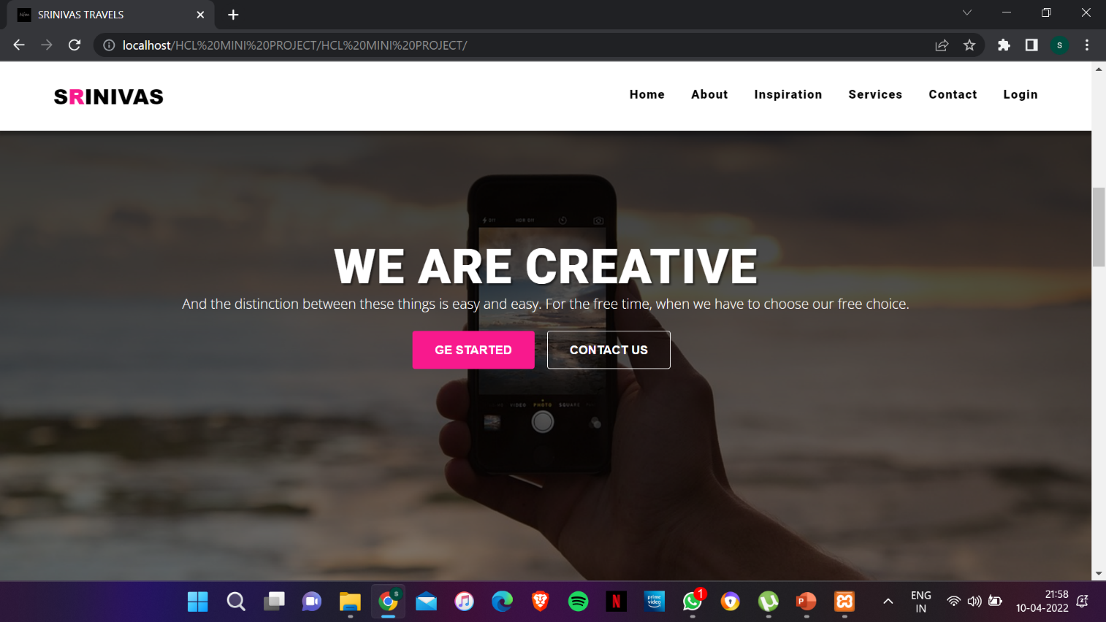

Fig 1.1: Home Page

6

* **About Us Page:**

This page contains the information about the tickets ready application, so that the passengers can have a better knowledge about this app.

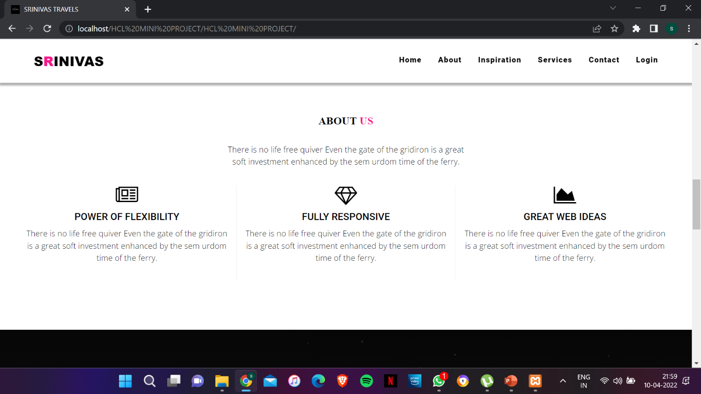

Fig 1.2: About Us Page

7

* **Contact Us page:**

In contact page, the passengers can contact the authorities of tickets ready app in order to get any help or any technical issues in the application. The authorities will give a clear solution for the problem.

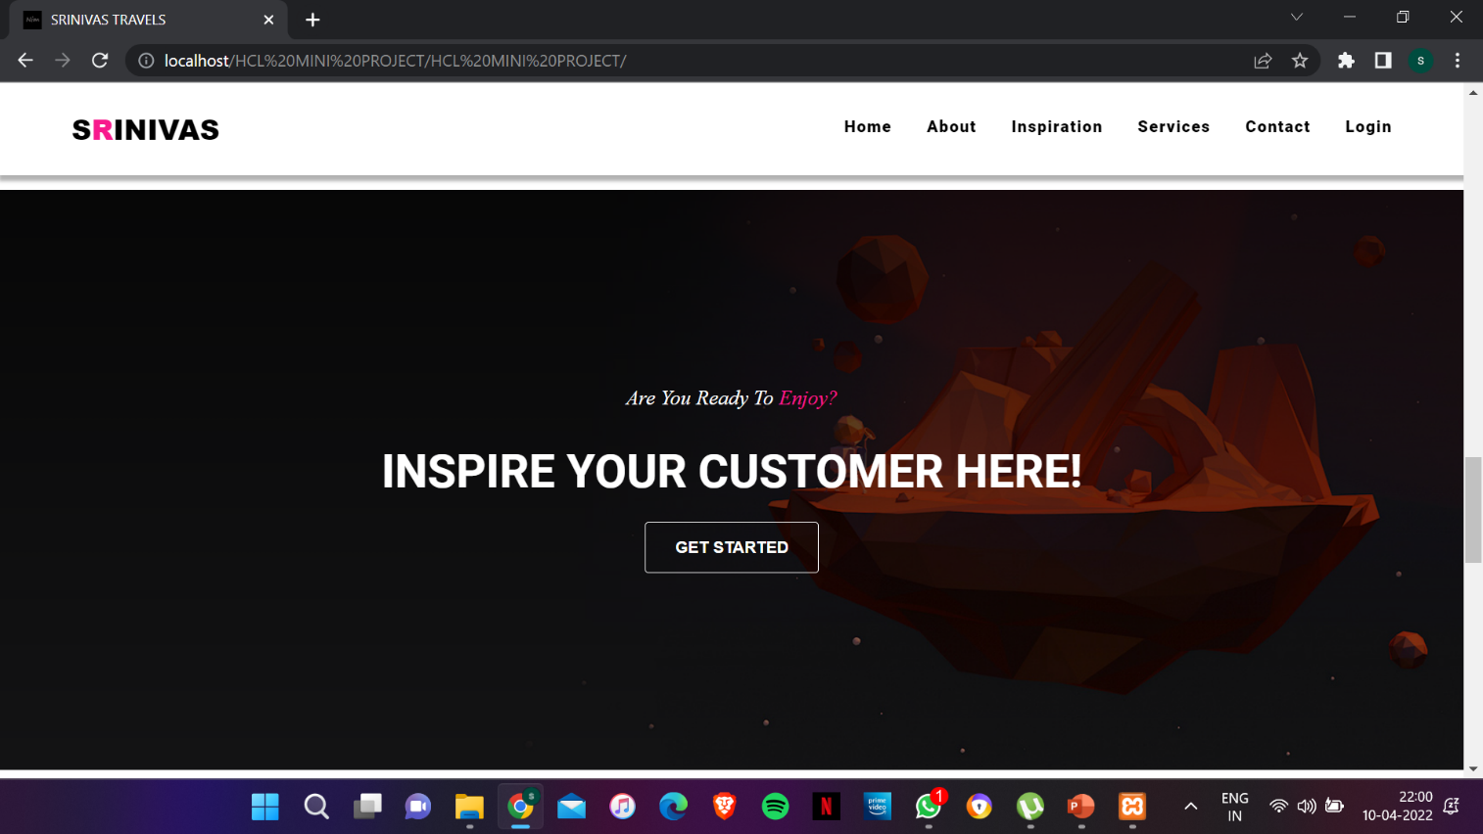

Fig 1.3: Contact Us Page

8

* **Services Page:**

This page gives the information about the other featured services that are offered by this application. The passengers can also make use of those extra features, but the main one is for booking tickets.

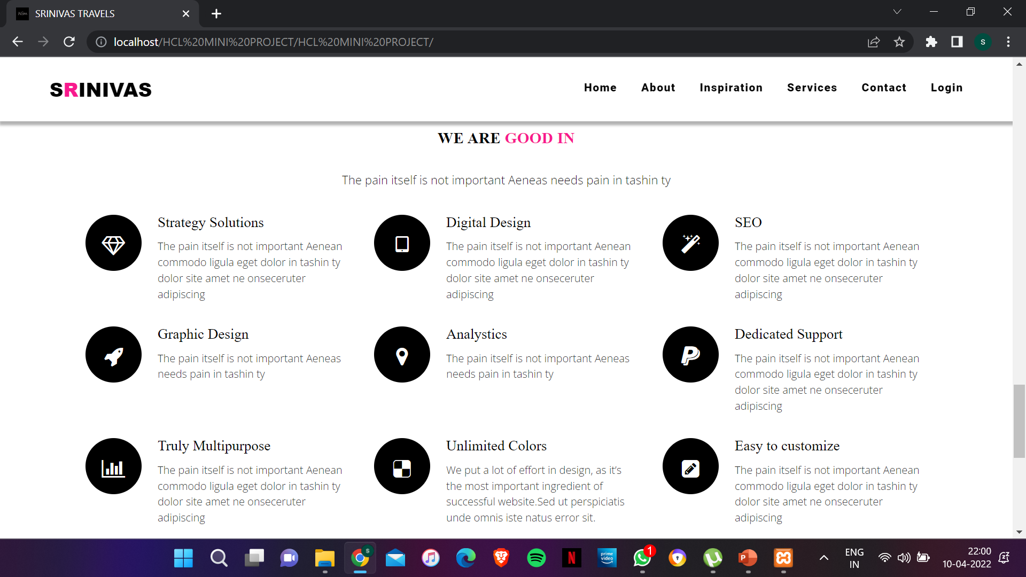

Fig 1.4: Services Page

9

* **Schedule Page:**

In this page, the passenger should enter the boarding point, destination point and the date of journey. This page is for selecting the schedule of the journey.

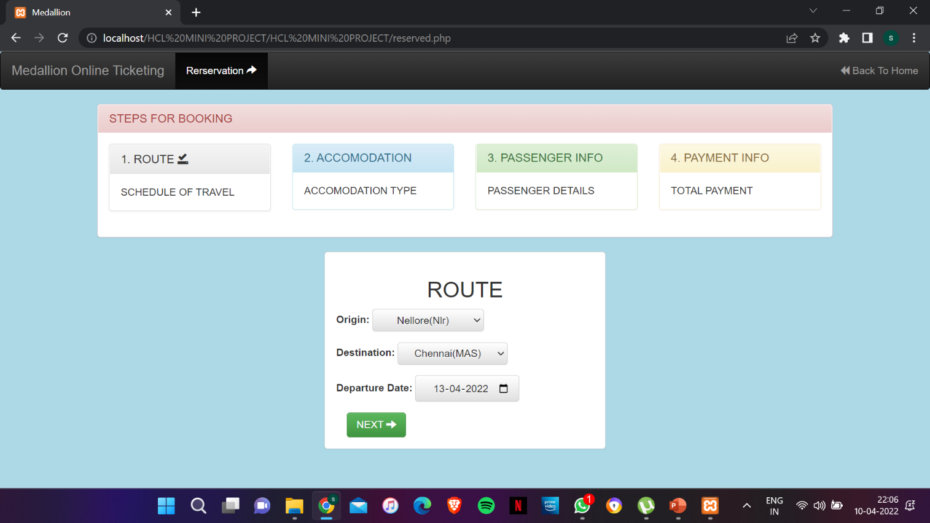

Fig 1.5: Schedule Page

10

* **Accommodation Page:**

This page is for passengers to select their class of seating based on number of slots available and fare of ticket. Here the number of passengers should be entered.

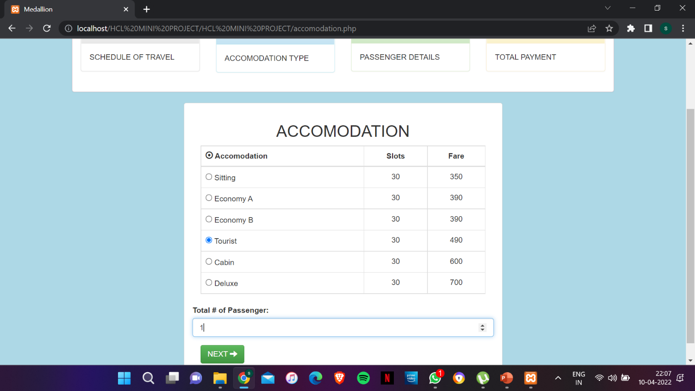

Fig 1.6: Accommodation Page

11

* **Passenger Info Page:**

In this page, passenger has to enter the details of the ticket booking person and the passengers who are going to travel. The details are their name, age and gender etc.

|  |  |
| --- | --- |
| FIELDS | VALIDATIONS |
| Booked By | Required |
| Contact | Required, Minlength=10 |
| Address | Required |
| Name | Required |
| Age | Required |
| Gender | Required |

Table 2.1: Passenger Info Fields

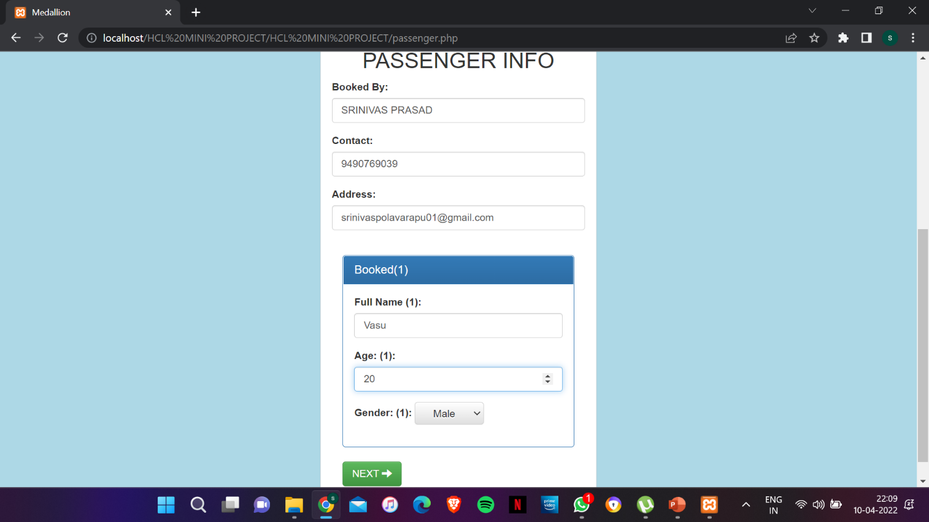

Fig 1.7: Passenger Info Page

12

* **Payment Info Page:**

This page contains the booking confirmation (the final ticket) with all information entered by the passenger in the above steps. It is the ticket for the entire journey.

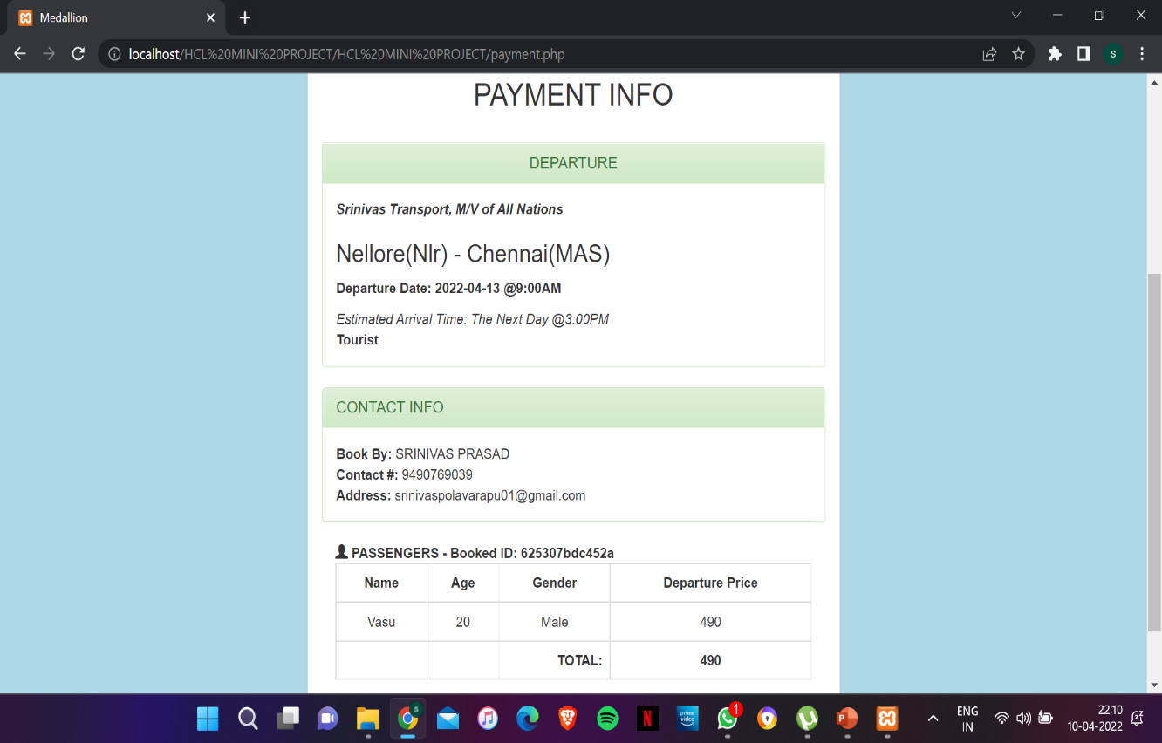

Fig 1.8: Payment Info Page

13

* **Login (for admin purpose):**

This page is for the admin purpose where admin can control all the booked passengers list and control the transactions by declining ticket or by giving concession for the passengers and provide refund to passengers who booked and cancelled their ticket.

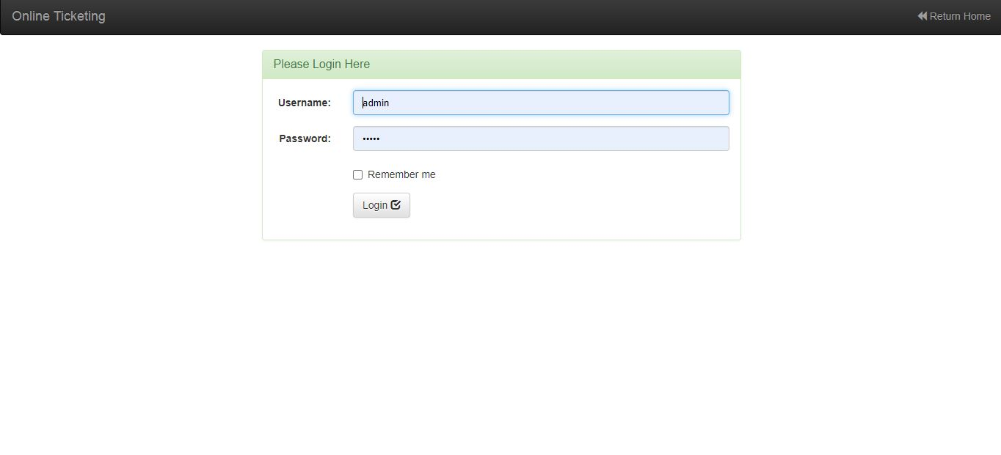

Fig 1.9: Login Page

1. **Reserved User Page:**

This page contains the list of all passengers booked the ticket using this app. Admin can control the list.

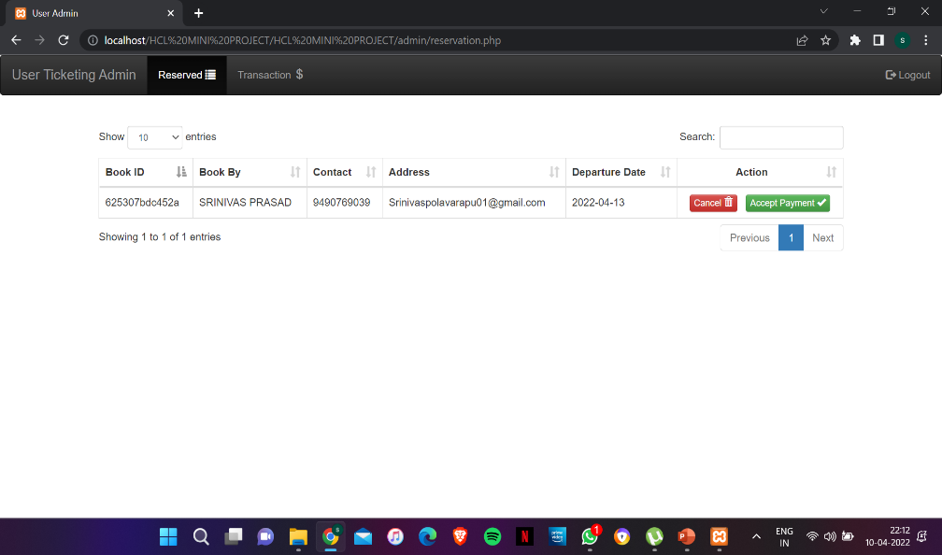

Fig 1.9.1: Reserved User Page

14

1. **Accept Payment Page:**

In this page, admin can accept the payment from the passengers as per the wish.

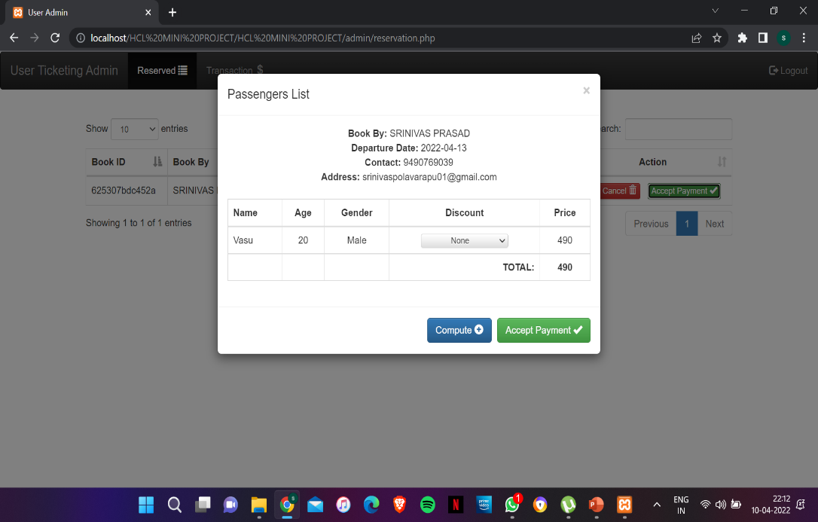

Fig 1.9.2: Accept Payment Page

1. **Transactions Page:**

In this page, admin can control the transactions by giving concession to the passengers by percentage basis.

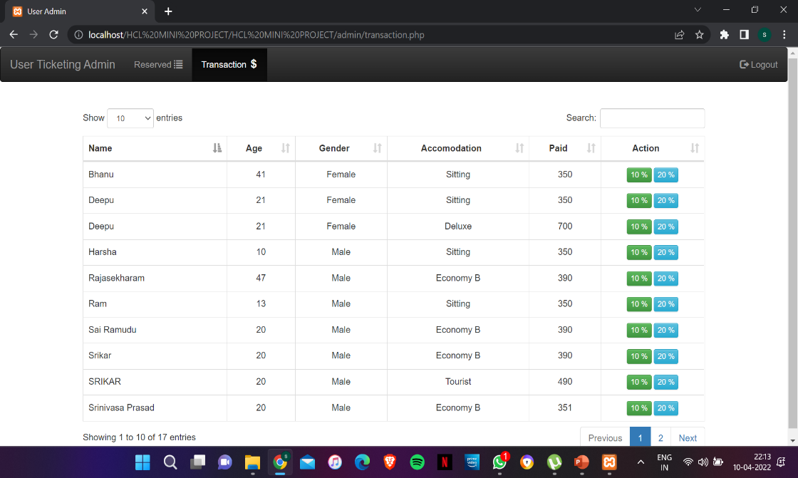

Fig 1.9.3: Transactions Page

15

* **BACKEND:**

The backend duties involve the MYSQL connection and a service. For the backend actions, a php document is done in backend and thereby the MYSQL database is connected to the application.

For this to be carried out first of all a mysql database should be created and thereby it should be connected with backend through the php code via connection link.

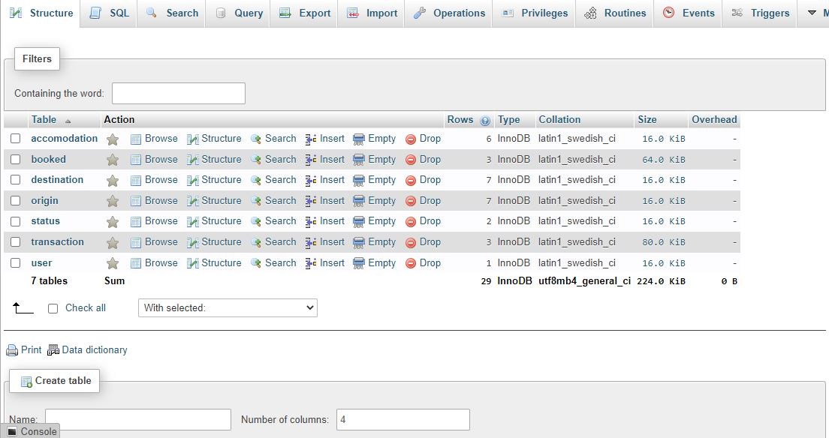

Fig 2: MYSQL Connection

16

**SUMMARY AND CONCLUSIONS**

* **SUMMARY:**
* This “Tickets Ready” app helps in booking your tickets in a quick manner and in affordable price for all people in the society.
* In this busy and hectic world, one cannot go to the booking office to book tickets and it’s a waste of time for people who are running to earn money.
* This app helps in a very good manner for those people and for female passengers it’s a very good advantage to get concession in ticket fare.
* The code is done from the scratch and the layout is made. The data is passed through database and collected in mysql. This will be more helpful in booking!!!

* **CONCLUSION:**
* The front-end languages such as HTML, CSS are becoming one among the emerging languages.
* This website is connected to backend and thus collecting the total details about the journey becomes very easy.
* In today’s world, the web development technology is an emerging technique which helps in many real time applications and saves people time and efforts.

17

**REFERENCES:**

IRCTC – A very known central government aided ticket reservation app that can be downloaded from Google play store has been taken as reference.

**APPENDIX**

1. SOURCE CODE

* Main html page:

<!DOCTYPE html>

<head>

<meta charset="utf-8">

<meta name="viewport" content="width=devidev-width, initial-scale=1.0, maximum-scale=1.0, user-scalable=no">

<meta http-equiv="X-UA-Compatible" content="IE=edge">

  <title>SRINIVAS TRAVELS</title>

<!-- [ FONT-AWESOME ICON ]

=========================================================================================================================-->

<link rel="stylesheet" type="text/css" href="library/font-awesome-4.3.0/css/font-awesome.min.css">

<!-- [ PLUGIN STYLESHEET ]

=========================================================================================================================-->

<link rel="shortcut icon" type="image/x-icon" href="images/icon.png">

<link rel="stylesheet" type="text/css" href="css/animate.css">

<link rel="stylesheet" type="text/css" href="css/owl.carousel.css">

<link rel="stylesheet" type="text/css" href="css/owl.theme.css">

<link rel="stylesheet" type="text/css" href="css/magnific-popup.css">

<!-- [ Boot STYLESHEET ]

=========================================================================================================================-->

<link rel="stylesheet" type="text/css" href="library/bootstrap/css/bootstrap-theme.min.css">

<link rel="stylesheet" type="text/css" href="library/bootstrap/css/bootstrap.css">

<!-- [ DEFAULT STYLESHEET ]

=========================================================================================================================-->

<link rel="stylesheet" type="text/css" href="css/style.css">

<link rel="stylesheet" type="text/css" href="css/responsive.css">

<link rel="stylesheet" type="text/css" href="css/color/rose.css">

</head>

<body >

<!-- [ LOADERs ]

================================================================================================================================-->

    <div class="preloader">

<div class="loader theme_background_color">

<span></span>

</div>

</div>

<!-- [ /PRELOADER ]

=============================================================================================================================-->

<!-- [WRAPPER ]

=============================================================================================================================-->

<div class="wrapper">

<!-- [NAV]

============================================================================================================================-->

<!-- Navigation

    ==========================================-->

<nav  class=" nim-menu navbar navbar-default navbar-fixed-top">

<div class="container">

<!-- Brand and toggle get grouped for better mobile display -->

<div class="navbar-header">

<button type="button" class="navbar-toggle collapsed" data-toggle="collapse" data-target="#bs-example-navbar-collapse-1">

<span class="sr-only">Toggle navigation</span>

<span class="icon-bar"></span>

<span class="icon-bar"></span>

<span class="icon-bar"></span>

</button>

<a class="navbar-brand" href="index.html">S<span class="themecolor">R</span>INIVAS</a>

</div>

<!-- Collect the nav links, forms, and other content for toggling -->

<div class="collapse navbar-collapse" id="bs-example-navbar-collapse-1">

<ul class="nav navbar-nav navbar-right">

<li><a href="#home" class="page-scroll"><h3>Home</h3></a></li>

<li><a href="#two" class="page-scroll"><h3>About</h3></a></li>

<li><a href="#one" class="page-scroll"><h3>Inspiration</h3></a></li>

<li><a href="#three" class="page-scroll"><h3>Services</h3></a></li>

<li><a href="#four" class="page-scroll"><h3>Contact</h3></a></li>

<li><a href="admin/" class="page-scroll"><h3>Login</h3></a></li>

</ul>

</div>

<!-- /.navbar-collapse -->

</div><!-- /.container-fluid -->

</nav>

<!-- [/NAV]

============================================================================================================================-->

<!-- [/MAIN-HEADING]

============================================================================================================================-->

<section class="main-heading" id="home">

<div class="overlay">

<div class="container">

<div class="row">

<div class="main-heading-content col-md-12 col-sm-12 text-center">

<h1 class="main-heading-title"><span class="main-element themecolor" data-elements=" Srinivas Online, Srinivas Online, Srinivas Online"></span></h1>

<h1 class="main-heading-title"><span class="main-element themecolor" data-elements=" Ticket Reservation, Ticket Reservation, Ticket Reservation"></span></h1>

<p class="main-heading-text"><br/></p>

<div class="btn-bar">

<a href="reserved.php" class="btn btn-custom theme_background_color">Reserved Now</a>

</div>

</div>

</div>

</div>

</div>

</section>

<section class="main-heading" id="home">

<div class="overlay">

<div class="container">

<div class="row">

<div class="main-heading-content col-md-12 col-sm-12 text-center">

<h1 class="main-heading-title">We are Creative</h1>

<p class="main-heading-text">And the distinction between these things is easy and easy. For the free time,

when we have to choose our free choice.</p>

<div class="btn-bar">

<a href="#" class="btn btn-custom theme_background_color">Ge Started</a>

<a href="#" class="btn btn-custom-outline">Contact Us</a>

</div>

</div>

</div>

</div>

</div>

</section>

<!-- [/MAIN-HEADING]

============================================================================================================================-->

<!-- [ABOUT US]

============================================================================================================================-->

<section class="aboutus white-background black" id="one">

<div class="container">

<div class="row">

<div class="col-md-12 text-center black">

<h3 class="title">ABOUT <span class="themecolor">US</span></h3>

<p class="a-slog">There is no life free quiver Even the gate of the gridiron is a great soft investment enhanced by the sem urdom time of the ferry.</p>

</div>

</div>

<div class="gap">

</div>

<div class="row about-box">

<div class="col-sm-4 text-center">

<div class="margin-bottom">

<i class="fa fa-newspaper-o"></i>

<h4>POWER OF FLEXIBILITY</h4>

<p class="black">There is no life free quiver Even the gate of the gridiron is a great soft investment enhanced by the sem urdom time of the ferry.</p>

</div> <!-- / margin -->

</div> <!-- /col -->

<div class="col-sm-4 about-line text-center">

<div class="margin-bottom">

<i class="fa fa-diamond"></i>

<h4>FULLY RESPONSIVE</h4>

<p class="black">There is no life free quiver Even the gate of the gridiron is a great soft investment enhanced by the sem urdom time of the ferry.</p>

</div> <!-- / margin -->

</div><!-- /col -->

<div class="col-sm-4 text-center">

<div class="margin-bottom">

<i class="fa fa-area-chart"></i>

<h4>GREAT WEB IDEAS</h4>

<p class="black">There is no life free quiver Even the gate of the gridiron is a great soft investment enhanced by the sem urdom time of the ferry.</p>

</div> <!-- / margin -->

</div><!-- /col -->

</div> <!-- /row -->

</div>

 </section>

<!-- [/ABOUTUS]

============================================================================================================================-->

<!-- [INSPIRATION]

============================================================================================================================-->

<section class="inspiration" id="four">

<div class="overlay">

<div class="container">

<div class="row">

 <article class="col-md-12 text-center">

 <div class="intermediate-container">

 <div class="subheading">

 <h4>Are You Ready To <span class="themecolor">Enjoy?</span></h4>

   </div>

 <div class="heading">

  <h2>inspire your customer here!</h2>

    </div>

<div class="">

  <a class="btn btn-custom-outline" href="#"><span>get started</span></a>

      </div>

    </div>

   </article>

      </div>

    </div>

 </div>

</section>

<!-- [/INSPIRATION]

============================================================================================================================-->

<!-- [/SERVICES]

============================================================================================================================-->

<section class="services white-background black" id="seven">

 <div class="container">

<div class="row text-center">

<div class="col-md-12">

<h3 class="title">We Are <span class="themecolor">Good In</span></h3>

<p class="a-slog">The pain itself is not important Aeneas needs pain in tashin ty</p>

</div> <!-- /col -->

</div> <!-- /row -->

<div class="gap"></div>

<div class="row">

<div class="col-sm-4">

<div class="nim-service margin-bottom">

<i class="fa fa-diamond"></i>

<div class="nim-service-detail">

<h4>Strategy Solutions</h4>

<p>The pain itself is not important Aenean commodo ligula eget dolor in tashin ty dolor site amet ne onseceruter adipiscing</p>

           </div> <!-- /nim-service-detail -->

</div> <!-- /nim-service margin-bottom -->

</div> <!-- /col -->

<div class="col-sm-4">

<div class="nim-service margin-bottom">

 <i class="fa fa-tablet"></i>

 <div class="nim-service-detail">

  <h4>Digital Design</h4>

  <p>The pain itself is not important Aenean commodo ligula eget dolor in tashin ty dolor site amet ne onseceruter adipiscing</p>

             </div> <!-- /nim-service-detail -->

</div> <!-- /nim-service margin-bottom -->

</div> <!-- /col -->

<div class="col-sm-4">

<div class="nim-service margin-bottom">

<i class="fa fa-magic"></i>

<div class="nim-service-detail">

<h4>SEO</h4>

<p>The pain itself is not important Aenean commodo ligula eget dolor in tashin ty dolor site amet ne onseceruter adipiscing</p>

             </div> <!-- /nim-service-detail -->

</div> <!-- /nim-service margin-bottom -->

 </div> <!-- /col -->

</div> <!-- end row -->

<div class="row">

<div class="col-sm-4">

<div class="nim-service margin-bottom">

 <i class="fa fa-rocket"></i>

 <div class="nim-service-detail">

 <h4>Graphic Design</h4>

<p>The pain itself is not important Aeneas needs pain in tashin ty</p>

    </div> <!-- /nim-service-detail -->

</div> <!-- /nim-service margin-bottom -->

 </div> <!-- /col -->

<div class="col-sm-4">

 <div class="nim-service margin-bottom">

<i class="fa fa-map-marker"></i>

<div class="nim-service-detail">

<h4>Analystics</h4>

<p>The pain itself is not important Aeneas needs pain in tashin ty</p>

 </div> <!-- /nim-service-detail -->

</div> <!-- /nim-service margin-bottom -->

</div> <!-- /col -->

<div class="col-sm-4">

<div class="nim-service margin-bottom">

 <i class="fa fa-paypal"></i>

<div class="nim-service-detail">

 <h4>Dedicated Support</h4>

<p>The pain itself is not important Aenean commodo ligula eget dolor in tashin ty dolor site amet ne onseceruter adipiscing</p>

</div> <!-- /nim-service-detail -->

</div> <!-- /nim-service margin-bottom -->

</div> <!-- /col -->

</div> <!-- end row -->

<div class="row">

<div class="col-sm-4">

<div class="nim-service margin-bottom">

 <i class="fa fa-bar-chart-o"></i>

<div class="nim-service-detail">

<h4>Truly Multipurpose</h4>

 <p>The pain itself is not important Aenean commodo ligula eget dolor in tashin ty dolor site amet ne onseceruter adipiscing</p>

 </div> <!-- /nim-service-detail -->

 </div> <!-- /nim-service margin-bottom -->

</div> <!-- /col -->

<div class="col-sm-4">

<div class="nim-service margin-bottom">

<i class="fa fa-delicious"></i>

<div class="nim-service-detail">

 <h4>Unlimited Colors</h4>

<p>We put a lot of effort in design, as it’s the most important ingredient of successful website.Sed ut perspiciatis unde omnis iste natus error sit.</p>

</div> <!-- /nim-service-detail -->

</div> <!-- /nim-service margin-bottom -->

 </div> <!-- /col -->

<div class="col-sm-4">

 <div class="nim-service margin-bottom">

<i class="fa fa-pencil-square"></i>

 <div class="nim-service-detail">

<h4>Easy to customize</h4>

<p>The pain itself is not important Aenean commodo ligula eget dolor in tashin ty dolor site amet ne onseceruter adipiscing</p>

 </div> <!-- /nim-service-detail -->

</div> <!-- /nim-service margin-bottom -->

</div> <!-- /col -->

 </div> <!-- end row -->

</div>  <!-- container -->

</section>

<!-- [/SERVICES]

============================================================================================================================-->

<!-- [CONTACT]

============================================================================================================================-->

<!--sub-form-->

<section class="sub-form text-center" id="eight">

<div class="container">

    <div class="col-md-12">

<h3 class="title">Subscribe to our <span class="themecolor"> News letter</span></h3>

<p class="lead">Have a happy booking</p>

</div>

<div class="row">

<div class="col-md-3 col-sm-3"></div>

<div class="col-md-6 center-block col-sm-6 ">

<form id="mc-form">

<div class="input-group">

<input type="email" class="form-control" placeholder="Email Address" required id="mc-email">

<span class="input-group-btn">

<button type="submit" class="btn btn-default">SUBSCRIBE <i class="fa fa-envelope"></i> </button>

</span> </div>

<label for="mc-email" id="mc-notification"></label>

 </form>

</div>

 </div>

</div>

</section>

<!--sub-form end-->

<!-- [/CONTACT]

============================================================================================================================-->

<!-- [FOOTER]

============================================================================================================================-->

<footer class="site-footer section-spacing text-center " id="eight">

<div class="container">

<div class="row">

<div class="col-md-4">

<p class="footer-links"><a href="#">Terms of Use</a> <a href="#">Privacy Policy</a></p>

</div>

<div class="col-md-4"> <small>&copy; 2021 Nim. All rights reserved.</small></div>

<div class="col-md-4">

<!--social-->

<ul class="social">

<li><a href="https://twitter.com/" target="_blank"><i class="fa fa-twitter "></i></a></li>

<li><a href="https://www.facebook.com/" target="_blank"><i class="fa fa-facebook"></i></a></li>

<li><a href="https://www.youtube.com/" target="_blank"><i class="fa fa-youtube-play"></i></a></li>

</ul>

<!--social end-->

</div>

</div>

</div>

</footer>

<!-- [/FOOTER]

============================================================================================================================-->

</div>

<!-- [ /WRAPPER ]

=============================================================================================================================-->

<!-- [ DEFAULT SCRIPT ] -->

<script src="library/modernizr.custom.97074.js"></script>

<script src="library/jquery-1.11.3.min.js"></script>

<script src="library/bootstrap/js/bootstrap.js"></script>

<script type="text/javascript" src="js/jquery.easing.1.3.js"></script>

<!-- [ PLUGIN SCRIPT ] -->

<script src="library/vegas/vegas.min.js"></script>

<script src="js/plugins.js"></script>

<!-- [ TYPING SCRIPT ] -->

<script src="js/typed.js"></script>

<!-- [ COUNT SCRIPT ] -->

<script src="js/fappear.js"></script>

<script src="js/jquery.countTo.js"></script>

<!-- [ SLIDER SCRIPT ] -->

<script src="js/owl.carousel.js"></script>

<script src="js/jquery.magnific-popup.min.js" type="text/javascript"></script>

<script type="text/javascript" src="js/SmoothScroll.js"></script>

<!-- [ COMMON SCRIPT ] -->

  <script src="js/common.js"></script>

</body>

</html>

* **Schedule Page:**

<?php

require_once('session_login.php');

 ?>

 <!DOCTYPE html>

<html lang="">

    <head>

        <meta charset="utf-8">

        <meta http-equiv="X-UA-Compatible" content="IE=edge">

        <meta name="viewport" content="width=device-width, initial-scale=1">

        <title>User Admin</title>

        <!-- Bootstrap CSS -->

    <link rel="stylesheet" type="text/css" href="../assets/css/bootstrap.min.css">

    <link rel="stylesheet" type="text/css" href="../assets/css/bootstrap-theme.min.css">

     <!-- Custom CSS -->

    <link href="../assets/css/simple-sidebar.css" rel="stylesheet">

    <link href="../assets/css/dataTables.bootstrap.min.css" rel="stylesheet">

    </head>

<body>

<nav class="navbar navbar-inverse">

    <div class="container-fluid">

        <a class="navbar-brand" href="#">User Ticketing Admin</a>

        <ul class="nav navbar-nav">

            <li class="active"><a href="reservation.php">Reserved

            <span class="glyphicon glyphicon-list" aria-hidden="true"></span>

            </a></li>

            <li class=""><a href="transaction.php">Transaction

            <span class="glyphicon glyphicon-usd" aria-hidden="true"></span>

            </a></li>

        </ul>

        <ul class="nav navbar-nav navbar-right">

          <li><a href="../admin/logout.php"><span class="glyphicon glyphicon-log-out"></span> Logout</a></li>

        </ul>

    </div>

</nav>

<br />

<div class="container-fluid">

    <div class="col-md-1"></div>

    <div class="col-md-10">

        <div id="book-table"></div>

    </div>

    <div class="col-md-1"></div>

</div>

<?php require_once('modal/view_passenger.php'); ?>

<?php require_once('modal/message.php'); ?>

<?php require_once('modal/confirmation.php'); ?>

<script type="text/javascript" src="../assets/js/jquery-3.1.1.min.js"></script>

<script type="text/javascript" src="../assets/js/bootstrap.min.js"></script>

<script type="text/javascript" src="../assets/js/jquery.dataTables.min.js"></script>

<script type="text/javascript" src="../assets/js/dataTables.bootstrap.min.js"></script>

<script type="text/javascript">

    function showAllBook(){

        $.ajax({

                url: '../data/get_all_book.php',

                type: 'post',

                // data: {},

                success: function (data) {

                    // console.log(data);

                    $('#book-table').html(data);

                },

                error: function(){

                    alert('Error: L54+');

                }

            });

    }//end showAllBook

    showAllBook();

    var book_tracker;

    function deleteBook(tracker){

        // console.log(tracker);

        book_tracker = tracker;

        $('#modal-confirmation').modal('show');

    }//end deleteBook

    $('.del-book').click(function(event) {

        /* Act on the event */

        $.ajax({

                url: '../data/deleteBook.php',

                type: 'post',

                dataType: 'json',

                data: {

                    tracker : book_tracker

                },

                success: function (data) {

                    // console.log(data);

                    $('#modal-confirmation').modal('hide');

                    showAllBook();

                    $('#modal-message').find('.modal-body').text(data.msg);

                    $('#modal-message').modal('show');

                },

                error: function(){

                    alert('Error: L87+');

                }

            });

    });//del

    function displayPassenger(tracker){

        // console.log(tracker);

        $.ajax({

                url: '../data/getPassengers.php',

                type: 'post',

                // dataType: 'json',

                data: {

                    tracker : tracker

                },

                success: function (data) {

                    // console.log(data);

                    $('#passenger-list').html(data);

                },

                error: function(){

                    alert('Error: L113+');

                }

            });

    }//end displayPassenger

    function viewBook(tracker){

        // $('#modal-view-pass').modal('show');

        $.ajax({

                url: '../data/getBookBy.php',

                type: 'post',

                dataType: 'json',

                data: {

                    tracker : tracker

                },

                success: function (data) {

                    // console.log(data);

                    $('#book-by').text(data.book_by);

                    $('#date').text(data.book_departure);

                    $('#contact').text(data.book_contact);

                    $('#address').text(data.book_address);

                    $('#modal-view-pass').modal('show');

                },

                error: function(){

                    alert('Error: L113+');

                }

            });

        displayPassenger(tracker);

    }//end viewBook

    function acceptPayment(){

        var counter = $('#i').val();

        var tot = 0;

        for(var i = 0; i < counter; i++){

            var name = $('#name'+i).val();

            var disc = $('#disc'+i).val();

            var price = $('#price'+i).val();

            var discounted = price * disc;

            $('#pri'+i).text(discounted);

            tot += Number(discounted);

        }//for loop

        $('#total').text(tot);

    }//end acceptPayment

    function addTransaction(){

        var counter = $('#i').val();

        var tot = 0;

        for(var i = 0; i < counter; i++){

            var name = $('#name'+i).val();

            var disc = $('#disc'+i).val();

            var price = $('#price'+i).val();

            var discounted = price * disc;

            $('#pri'+i).text(discounted);

            tot += Number(discounted);

                $.ajax({

                    url: '../data/save_transaction.php',

                    type: 'post',

                    dataType: 'json',

                    data: {

                        bid : name,

                        disc : disc

                    },

                    success: function (data) {

                        console.log(data);

                        $('#modal-view-pass').modal('hide');

                        showAllBook();

                        $('#modal-message').find('.modal-body').text('Transaction Save Successfully!');

                        $('#modal-message').modal('show');

                    },

                    error: function(){

                        alert('Error: L162+');

                    }

                });

        }//for loop

        $('#total').text(tot);

    }

</script>

</body>

</html>

* **Accommodation page**:

<?php

if(session_status() == PHP_SESSION_NONE)

{

    session_start();//start session if session not start

}

if(isset($_SESSION['departure_date'])){

?>

<!DOCTYPE html>

<html lang="">

    <head>

        <meta charset="utf-8">

        <meta http-equiv="X-UA-Compatible" content="IE=edge">

        <meta name="viewport" content="width=device-width, initial-scale=1">

        <title>Medallion</title>

        <!-- Bootstrap CSS -->

    <link rel="stylesheet" type="text/css" href="assets/css/bootstrap.min.css">

    <link rel="stylesheet" type="text/css" href="assets/css/bootstrap-theme.min.css">

    </head>

<body style="background-color: lightblue;">

<nav class="navbar navbar-inverse">

  <div class="container-fluid">

    <div class="navbar-header">

      <a class="navbar-brand" href="#">Medallion Online Ticketing</a>

    </div>

    <ul class="nav navbar-nav">

      <li class="active">

        <a href="#">Rerservation

        <span class="glyphicon glyphicon-share-alt" aria-hidden="true"></span>

        </a>

      </li>

    </ul>

    <ul class="nav navbar-nav navbar-right">

      <li><a href="index.php"><span class="glyphicon glyphicon-backward"></span> Back To Home</a></li>

    </ul>

  </div>

</nav>

<div class="container-fluid">

    <div class="col-md-1"></div>

    <div class="col-md-10">

        <div class="panel panel-danger">

            <div class="panel-heading">

                <h3 class="panel-title">STEPS FOR BOOKING</h3>

            </div>

            <div class="panel-body">

                <div class="row">

                    <div class="col-md-3">

                        <div class="panel panel-default">

                            <div class="panel-heading">

                                <h3 class="panel-title">1. ITINERARY

                                </h3>

                            </div>

                            <div class="panel-body">

                                SCHEDULE OF TRAVEL

                            </div>

                        </div>

                    </div>

                    <div class="col-md-3">

                        <div class="panel panel-info">

                            <div class="panel-heading">

                                <h3 class="panel-title">2. ACCOMODATION

                                <span class="glyphicon glyphicon-saved" aria-hidden="true"></span>

                                </h3>

                            </div>

                            <div class="panel-body">

                                ACCOMODATION TYPE

                            </div>

                        </div>

                    </div>

                    <div class="col-md-3">

                        <div class="panel panel-success">

                            <div class="panel-heading">

                                <h3 class="panel-title">3. PASSENGER INFO</h3>

                            </div>

                            <div class="panel-body">

                                PASSENGER DETAILS

                            </div>

                        </div>

                    </div>

                    <div class="col-md-3">

                        <div class="panel panel-warning">

                            <div class="panel-heading">

                                <h3 class="panel-title">4. PAYMENT INFO</h3>

                            </div>

                            <div class="panel-body">

                                TOTAL PAYMENT

                            </div>

                        </div>

                    </div>

                </div>

            </div>

        </div>

    </div>

    <div class="col-md-1"></div>

</div>

<div class="container-fluid">

    <div class="col-md-3"></div>

    <div class="col-md-6">

        <div class="panel panel-default">

            <div class="panel-body">

             <h2>

                <center>ACCOMODATION</center>

             </h2>

                <div class="container-fluid">

                    <form class="form-horizontal" role="form" id="form-acc">

                      <table id="myTable-party" class="table table-bordered table-hover" cellspacing="0" width="100%">

                            <thead>

                                <tr>

                                    <th> <span class="glyphicon glyphicon-record" aria-hidden="true"></span>

                                    Accomodation

                                    </th>

                                    <th>

                                        <center>

                                            Slots

                                        </center>

                                    </th>

                                    <th>

                                        <center>

                                            Fare

                                        </center>

                                    </th>

                                </tr>

                            </thead>

                            <tbody>

                                <?php require_once('data/get_all_accomodations.php'); ?>

                                <tr>

                                    <td>

                                        <input value="<?= $getSit['acc_id']; ?>" type="radio" name="acc">

                                        <?= $getSit['acc_type']; ?>

                                    </td>

                                    <td align="center">

                                        <?= $getSit['acc_slot'] - $totalSit['sit']; ?>

                                    </td>

                                    <td align="center"><?= $getSit['acc_price']; ?></td>

                                </tr>

                                <tr>

                                    <td>

                                        <input value="<?= $getEcoA['acc_id']; ?>" type="radio" name="acc">

                                        <?= $getEcoA['acc_type']; ?>

                                    </td>

                                    <td align="center">

                                        <?= $getEcoA['acc_slot'] - $totalEcoA['ecoA']; ?>

                                    </td>

                                    <td align="center"><?= $getEcoA['acc_price']; ?></td>

                                </tr>

                                <tr>

                                    <td>

                                        <input value="<?= $getEcoB['acc_id']; ?>" type="radio" name="acc">

                                        <?= $getEcoB['acc_type']; ?>

                                    </td>

                                    <td align="center">

                                        <?= $getEcoB['acc_slot'] - $totalEcoB['ecoB']; ?>

                                    </td>

                                    <td align="center"><?= $getEcoB['acc_price']; ?></td>

                                </tr>

                                <tr>

                                    <td>

                                        <input value="<?= $getTour['acc_id']; ?>" type="radio" name="acc">

                                        <?= $getTour['acc_type']; ?>

                                    </td>

                                    <td align="center">

                                        <?= $getTour['acc_slot'] - $totalTour['ecoT']; ?>

                                    </td>

                                    <td align="center"><?= $getTour['acc_price']; ?></td>

                                </tr>

                                <tr>

                                    <td>

                                        <input value="<?= $getCab['acc_id']; ?>" type="radio" name="acc">

                                        <?= $getCab['acc_type']; ?>

                                    </td>

                                    <td align="center">

                                        <?= $getCab['acc_slot'] - $totalCab['ecoC']; ?>

                                    </td>

                                    <td align="center"><?= $getCab['acc_price']; ?></td>

                                </tr>

                                <tr>

                                    <td>

                                        <input value="<?= $getDel['acc_id']; ?>" type="radio" name="acc">

                                        <?= $getDel['acc_type']; ?>

                                    </td>

                                    <td align="center">

                                        <?= $getDel['acc_slot'] - $totalDel['ecoD']; ?>

                                    </td>

                                    <td align="center"><?= $getDel['acc_price']; ?></td>

                                </tr>

                            </tbody>

                        </table>

                      <div class="form-group">

                        <label for="">Total # of Passenger:</label>

                        <input type="number" min="1" class="form-control" name="totalPass" plactreholder="Total # of Passenger" autocomplete="off">

                      </div>

                      <button type="submit" class="btn btn-success">NEXT

                      <span class="glyphicon glyphicon-arrow-right" aria-hidden="true"></span>

                      </button>

                    </form>

                </div>

            </div>

        </div>

    </div>

    <div class="col-md-3"></div>

</div>

<script type="text/javascript" src="assets/js/jquery-3.1.1.min.js"></script>

<script type="text/javascript" src="assets/js/bootstrap.min.js"></script>

<script type="text/javascript">

    $(document).on('submit', '#form-acc', function(event) {

        event.preventDefault();

        /* Act on the event */

        var acc = $('input[name="acc"]:checked').val();

        var totalPass = $('input[name="totalPass"]').val();

        if(acc == null){

            alert('Please Select Accomodation!');

        }else{

            // console.log(acc);

            if(totalPass.length == 0){

                alert('Please Enter Number of Passenger!');

            }else{

                $.ajax({

                        url: 'data/session_accomodation.php',

                        type: 'post',

                        dataType: 'json',

                        data: {

                            acc : acc,

                            tp : totalPass

                        },

                        success: function (data) {

                            console.log(data.slot);

                            //  window.location = "passenger.php";

                            if(data.slot >= 0){

                                window.location = "passenger.php";

                            }else{

                                alert('Not Enough Slot!');

                            }

                        },

                        error: function(){

                            alert('Error: L175+');

                        }

                    });

            }//end totalPass

        }//end acc == null

    });

</script>

</body>

</html>

<?php

}else{

    echo '<strong>';

    echo 'Page Not Exist';

    echo '</strong>';

}//end if else isset

 ?>

32

* Passenger Info Page:

<?php

if(session_status() == PHP_SESSION_NONE)

{

    session_start();//start session if session not start

}

if(isset($_SESSION['accomodation'])){

?>

<!DOCTYPE html>

<html lang="">

    <head>

        <meta charset="utf-8">

        <meta http-equiv="X-UA-Compatible" content="IE=edge">

        <meta name="viewport" content="width=device-width, initial-scale=1">

        <title>Medallion</title>

        <!-- Bootstrap CSS -->

    <link rel="stylesheet" type="text/css" href="assets/css/bootstrap.min.css">

    <link rel="stylesheet" type="text/css" href="assets/css/bootstrap-theme.min.css">

    </head>

<body style="background-color: lightblue;">

<nav class="navbar navbar-inverse">

  <div class="container-fluid">

    <div class="navbar-header">

      <a class="navbar-brand" href="#">Medallion Online Ticketing</a>

    </div>

    <ul class="nav navbar-nav">

      <li class="active">

        <a href="#">Rerservation

        <span class="glyphicon glyphicon-share-alt" aria-hidden="true"></span>

        </a>

      </li>

    </ul>

    <ul class="nav navbar-nav navbar-right">

      <li><a href="index.php"><span class="glyphicon glyphicon-backward"></span> Back To Home</a></li>

    </ul>

  </div>

</nav>

<div class="container-fluid">

    <div class="col-md-1"></div>

    <div class="col-md-10">

        <div class="panel panel-danger">

            <div class="panel-heading">

                <h3 class="panel-title">STEPS FOR BOOKING</h3>

            </div>

            <div class="panel-body">

                <div class="row">

                    <div class="col-md-3">

                        <div class="panel panel-default">

                            <div class="panel-heading">

                                <h3 class="panel-title">1. ITINERARY

                                </h3>

                            </div>

                            <div class="panel-body">

                                SCHEDULE OF TRAVEL

                            </div>

                        </div>

                    </div>

                    <div class="col-md-3">

                        <div class="panel panel-info">

                            <div class="panel-heading">

                                <h3 class="panel-title">2. ACCOMODATION

                                </h3>

                            </div>

                            <div class="panel-body">

                                ACCOMODATION TYPE

                            </div>

                        </div>

                    </div>

                    <div class="col-md-3">

                        <div class="panel panel-success">

                            <div class="panel-heading">

                                <h3 class="panel-title">3. PASSENGER INFO

                                <span class="glyphicon glyphicon-saved" aria-hidden="true"></span>

                                </h3>

                            </div>

                            <div class="panel-body">

                                PASSENGER DETAILS

                            </div>

                        </div>

                    </div>

                    <div class="col-md-3">

                        <div class="panel panel-warning">

                            <div class="panel-heading">

                                <h3 class="panel-title">4. PAYMENT INFO</h3>

                            </div>

                            <div class="panel-body">

                                TOTAL PAYMENT

                            </div>

                        </div>

                    </div>

                </div>

            </div>

        </div>

    </div>

    <div class="col-md-1"></div>

</div>

<div class="container-fluid">

    <div class="col-md-4"></div>

    <div class="col-md-4">

        <div class="alert alert-danger">

            <button type="button" class="close" data-dismiss="alert" aria-hidden="true">&times;</button>

            <strong>Message!</strong> Please review your passenger information.

            You cannot change your reservation once you proceed.

        </div>

        <div class="panel panel-default">

            <div class="panel-body">

             <h2>

                <center>PASSENGER INFO</center>

             </h2>

                <div class="container-fluid">

                    <form class="form-horizontal" role="form" id="form-pass">

                      <div class="form-group">

                        <label for="">Booked By:</label>

                        <input type="text" class="form-control" id="book-by" placeholder="Enter Name"

                        autofocus="" required="" autocomplete="off">

                      </div>

                      <div class="form-group">

                        <label for="">Contact:</label>

                        <input type="text" class="form-control" id="cont" placeholder="Enter Contact" required="" autocomplete="off">

                      </div>

                      <div class="form-group">

                        <label for="">Address:</label>

                        <input type="text" class="form-control" id="address" placeholder="Enter Address" required="" autocomplete="off">

                      </div>

                    <br />

                    <?php

                        $tb = $_SESSION['totalPass'];

                        $count = 1;

                        for($i = 0; $i < $tb; $i++){

                    ?>

                      <div class="panel panel-primary">

                        <div class="panel-heading">

                            <h3 class="panel-title">Booked(<?= $count; ?>)</h3>

                        </div>

                        <div class="panel-body">

                            <div class="container-fluid">

                                <div class="form-group">

                                    <label for="">Full Name (<?= $count; ?>):</label>

                                    <input type="text" class="form-control" id="fN<?php echo $i; ?>"

                                    placeholder="Enter Fullname" required autocomplete="off">

                                  </div>

                                  <div class="form-group">

                                    <label for="">Age: (<?= $count; ?>):</label>

                                    <input type="number" class="form-control" id="age<?php echo $i; ?>"

                                    placeholder="Enter Age" required autocomplete="off">

                                  </div>

                                  <div class="form-group">

                                    <label for="">Gender: (<?= $count; ?>):</label>

                                    <select class="btn btn-default" id="gender<?php echo $i; ?>">

                                        <option value="Male">Male</option>

                                        <option value="Female">Female</option>

                                    </select>

                                  </div>

                            </div>

                        </div>

                      </div>

                    <?php

                    $count++;

                        }//end for

                     ?>

                      <button type="submit" class="btn btn-success">NEXT

                      <span class="glyphicon glyphicon-arrow-right" aria-hidden="true"></span>

                      </button>

                    </form>

                </div>

            </div>

        </div>

    </div>

    <div class="col-md-4"></div>

</div>

<?php require_once('admin/modal/message.php'); ?>

<script type="text/javascript" src="assets/js/jquery-3.1.1.min.js"></script>

<script type="text/javascript" src="assets/js/bootstrap.min.js"></script>

<script type="text/javascript">

    $(document).on('submit', '#form-pass', function(event) {

        event.preventDefault();

        /* Act on the event */

        var bookBy = $('#book-by').val();

        var cont = $('#cont').val();

        var address = $('#address').val();

        var counter = <?= $i; ?>;

        for(var i = 0; i < counter; i++){

            var fN = $('#fN'+i).val();

            var age = $('#age'+i).val();

            var gender = $('#gender'+i).val();

            $.ajax({

                    url: 'data/save_booked.php',

                    type: 'post',

                    dataType: 'json',

                    data: {

                        bookBy : bookBy,

                        cont : cont,

                        address : address,

                        fN : fN,

                        age : age,

                        gender : gender

                    },

                    success: function (data) {

                        // console.log(data);

                        if(data.valid == true){

                            window.location = data.url;

                        }

                    },

                    error: function(){

                        // alert('Error: L192+');

                    }

                });

        }//end for

        alert('Booked Successfully!');

    });

</script>

</body>

</html>

<?php

}else{

    echo '<strong>';

    echo 'Page Not Exist';

    echo '</strong>';

}//end if else isset

 ?>

36

* **Payment Info Page:**

<?php

if(session_status() == PHP_SESSION_NONE)

{

    session_start();//start session if session not start

}

if(isset($_SESSION['tracker'])){

?>

<!DOCTYPE html>

<html lang="">

    <head>

        <meta charset="utf-8">

        <meta http-equiv="X-UA-Compatible" content="IE=edge">

        <meta name="viewport" content="width=device-width, initial-scale=1">

        <title>Medallion</title>

        <!-- Bootstrap CSS -->

    <link rel="stylesheet" type="text/css" href="assets/css/bootstrap.min.css">

    <link rel="stylesheet" type="text/css" href="assets/css/bootstrap-theme.min.css">

    </head>

<body style="background-color: lightblue;">

<nav class="navbar navbar-inverse">

  <div class="container-fluid">

    <div class="navbar-header">

      <a class="navbar-brand" href="#">Medallion Online Ticketing</a>

    </div>

    <ul class="nav navbar-nav">

      <li class="active">

        <a href="#">Rerservation

        <span class="glyphicon glyphicon-share-alt" aria-hidden="true"></span>

        </a>

      </li>

    </ul>

    <ul class="nav navbar-nav navbar-right">

      <li><a href="index.php"><span class="glyphicon glyphicon-backward"></span> Back To Home</a></li>

    </ul>

  </div>

</nav>

<div class="container-fluid">

    <div class="col-md-1"></div>

    <div class="col-md-10">

        <div class="panel panel-danger">

            <div class="panel-heading">

                <h3 class="panel-title">STEPS FOR BOOKING</h3>

            </div>

            <div class="panel-body">

                <div class="row">

                    <div class="col-md-3">

                        <div class="panel panel-default">

                            <div class="panel-heading">

                                <h3 class="panel-title">1. ITINERARY

                                </h3>

                            </div>

                            <div class="panel-body">

                                SCHEDULE OF TRAVEL

                            </div>

                        </div>

                    </div>

                    <div class="col-md-3">

                        <div class="panel panel-info">

                            <div class="panel-heading">

                                <h3 class="panel-title">2. ACCOMODATION

                                </h3>

                            </div>

                            <div class="panel-body">

                                ACCOMODATION TYPE

                            </div>

                        </div>

                    </div>

                    <div class="col-md-3">

                        <div class="panel panel-success">

                            <div class="panel-heading">

                                <h3 class="panel-title">3. PASSENGER INFO

                                </h3>

                            </div>

                            <div class="panel-body">

                                PASSENGER DETAILS

                            </div>

                        </div>

                    </div>

                    <div class="col-md-3">

                        <div class="panel panel-warning">

                            <div class="panel-heading">

                                <h3 class="panel-title">4. PAYMENT INFO

                                    <span class="glyphicon glyphicon-saved" aria-hidden="true"></span>

                                </h3>

                            </div>

                            <div class="panel-body">

                                TOTAL PAYMENT

                            </div>

                        </div>

                    </div>

                </div>

            </div>

        </div>

    </div>

    <div class="col-md-1"></div>

</div>

<div class="container-fluid">

    <div class="col-md-3"></div>

    <div class="col-md-6">

        <div class="panel panel-default">

            <div class="panel-body">

             <h2>

                <center>PAYMENT INFO</center>

             </h2>

             <br />

             <div class="panel panel-success">

                <div class="panel-heading">

                    <h3 class="panel-title"><center>DEPARTURE</center></h3>

                </div>

                <div class="panel-body">

                    <strong>

                        <i>Srinivas Transport, M/V of All Nations</i>

                        <h3>

                        <?php require_once('data/depart_from_to.php');

                            echo $origin['origin_desc'];

                        ?>

                         -

                         <?= $dest['dest_destination']; ?>

                         </h3>

                        <p>Departure Date: <?= $_SESSION['departure_date']; ?> @9:00AM</p>

                    </strong>

                        <i>Estimated Arrival Time: The Next Day @3:00PM</i><br />

                        <strong>

                            <?php require_once('data/get_accomodation.php');

                                echo $accomodation['acc_type'];

                            ?>

                        </strong>

                </div>

             </div>

             <div class="panel panel-success">

                <div class="panel-heading">

                    <h3 class="panel-title">CONTACT INFO</h3>

                </div>

                <div class="panel-body">

                <?php require_once('data/getBooked.php'); ?>

                <strong>Book By:</strong> <?= ucwords($bookByInfo['book_by']);  ?><br />

                <strong>Contact #:</strong> <?= $bookByInfo['book_contact']; ?><br />

                <strong>Address:</strong> <?= $bookByInfo['book_address']; ?><br />

                </div>

             </div>

                <div class="container-fluid">

                <strong>

                <span class="glyphicon glyphicon-user" aria-hidden="true"></span>

                PASSENGERS</strong>

                    <table id="myTable-party" class="table table-bordered table-hover" cellspacing="0" width="100%">

                            <thead>

                                <tr>

                                    <th>

                                        <center>

                                            Name

                                        </center>

                                    </th>

                                    <th>

                                        <center>

                                            Age

                                        </center>

                                    </th>

                                    <th>

                                        <center>

                                            Gender

                                        </center>

                                    </th>

                                     <th>

                                        <center>

                                            Departure Price

                                        </center>

                                    </th>

                                </tr>

                            </thead>

                            <tbody>

                            <?php

                                require_once('data/getBooked.php');

                                $totalPayment = 0;

                                $tracker = '';

                             foreach($bookPass as $bp):

                                $name = $bp['book_name'];

                                $name = ucwords($name);

                                $price = $bp['acc_price'];

                                $totalPayment += $price;

                                $tracker = $bp['book_tracker'];

                            ?>

                                <tr align="center">

                                    <td><?= $name; ?></td>

                                    <td><?= $bp['book_age']; ?></td>

                                    <td><?= $bp['book_gender']; ?></td>

                                    <td><?= $price; ?></td>

                                </tr>

                            <?php endforeach; ?>

                                <tr>

                                    <td></td>

                                    <td></td>

                                    <td align="right"><strong>TOTAL:</strong></td>

                                    <td align="center"><strong><?= $totalPayment; ?></strong></td>

                                </tr>

                            </tbody>

                            <strong>- Booked ID: <?= $tracker; ?></strong>

                           </table>

                           <center>

                               <a href="index.php" class="btn btn-success">Return Home

                                   <span class="glyphicon glyphicon-backward" aria-hidden="true"></span>

                               </a>

                           </center>

                </div>

            </div>

        </div>

    </div>

    <div class="col-md-3"></div>

</div>

<script type="text/javascript" src="assets/js/jquery-3.1.1.min.js"></script>

<script type="text/javascript" src="assets/js/bootstrap.min.js"></script>

</body>

</html>

<?php

}else{

    echo '<strong>';

    echo 'Page Not Exist';

    echo '</strong>';

}//end if else isset

 ?>

40

1. SCREENSHOTS



41